AMT 02 - KAYAKING EXPEDITION URUBU RIVER 2D/1N
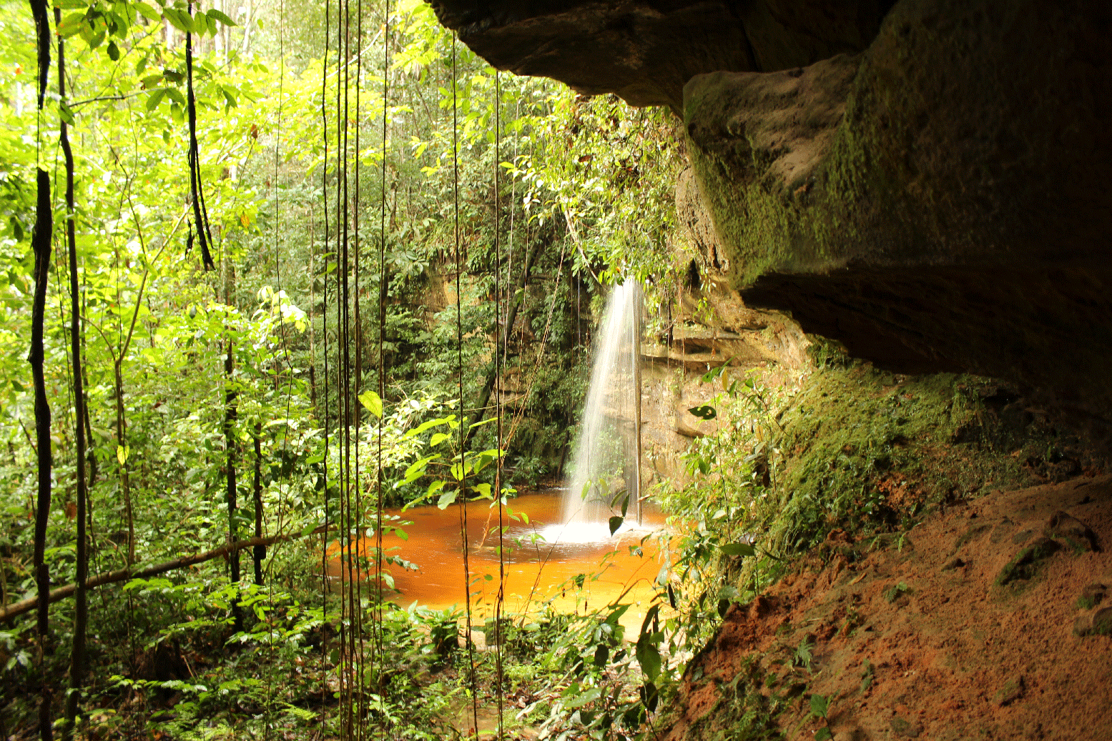

The Urubu River is a tributary of the great Amazon River, and lies to the east of Manaus. It is almost 500 km/310 miles long, and is the narrowest river we travel on – it is the perfect width to experience the real rainforest at your fingertips.

Few people live on this exciting river and you will enjoy peaceful days without seeing or hearing much of humanity at all. The predominantly gentle current will aid you in your journey downstream, although you may also have the chance to shoot some safe but exciting rapids.

Kayaking is the perfect way to experience this beautiful, mystical river before mass tourism discovers it!

SUMMARY OF ACTIVITIES

- Scenic kayaking
- Hikes through rare visited rainforest
- Overnight camp in the jungle
- Sunrise and sunset observation
- Meet local forest-dweller/caboclo families
- Explore a bat cave
- Hike to a remote and rarely seen waterfall
* Option to tailor activities as time and season permits - Description in the last pages

ITINERARY

Day 1
08:00 am We’ll meet you in the lobby of your hotel. You can enjoy the Amazonian scenery on the 2-hour drive to the shores of the Urubu, when you will get a feel for the native scenery and local infrastructure.

On arrival, your guide will give you a brief introduction to the kayaks - showing you how to safely enter and exit, how to paddle and steer, and how best to stow your gear. Then it will be into the water for a short swim to help you lose any fear of this beautiful, warm (24C/75F) black water.

11:00 am A little snack and it's time to go! We will kayak for around 2 hours through the luxuriant rainforest where blue and yellow macaws live. This will be your first taste of the true Amazon jungle, the river and its beautiful surroundings. On our first stop, you’ll be able to stretch your legs during our first hike through the rainforest to see an interesting bat cave often used in the breeding season.

Before leaving for another short stretch of kayaking, we’ll have a refreshing fruit snack - then we'll be on our way to our first campsite, where a nice hot meal will be waiting for us. This camp is located by the wall of a 25 meters (80 ft.) high cliff where tiny orchids cling tenaciously to the vertical surface. This is one of the options of camping it can change with the conditions of the river and season by the way another 2 others camp spots are possible like a dweller shelter or a beautiful beach to see all the stars in our close Line of Ecuador.

Camp will be set up by your guides while you relax and enjoy the famous Brazilian drink, caipirinha (sugar cane liquor with lime, sugar and ice). Your hammock will be covered with a mosquito net and a large tarpaulin on top in case of rain. Your guide will provide a demonstration of some techniques to help you get the best out of your hammock, and then it will be your turn. To minimize any risk of flipping over in your hammock, we suggest you learn these techniques before your third caipirinha ☺ A simple, hot and nutritious dinner will be served before we retire for the night.

Day 2
Breakfast will be served, nice opportunity to new experiences of smells and tastes, while you listen all the birds of this amazing place. We’ll kayaking around 1hr where we going to do our second hiking and visit 2 waterfalls in the same day. This peaceful place is possible jump from the waterfalls in this little stream with the best temperature to refresh our humidity. This hiking in general is made in 2hrs where is possible to have some good knowledge about our plants and first aid in the rainforest. Back to the place where we start the hiking is time to relax and very soon the lunch will be served, Siesta time and time to come back. Our way back is made by boat against the river is good time to take pictures of the way you did. In this way we’ll spent 2:30hrs+/- to the same place where we started our Kayaking experience.

Time to say good bye our van will waiting for us to our back to Manaus. Our estimate is in general is 2hrs driving to your hotel and finish our trip around 16:00 to 18:00.

There are a number of activities and sights available to us (see Activities in Detail). In consultation with your English speaking guide, you can adapt the precise itinerary according to your own specific interests or requirements. You can repeat, extend or skip activities as you wish – however bear in mind that the limiting factors will be the number of days you have, the water level, security, and your preferred pace. Your guide will help you decide and plan to get the best out of YOUR expedition

AMT 03 - KAYAKING EXPEDITION URUBU RIVER – 3D/2N

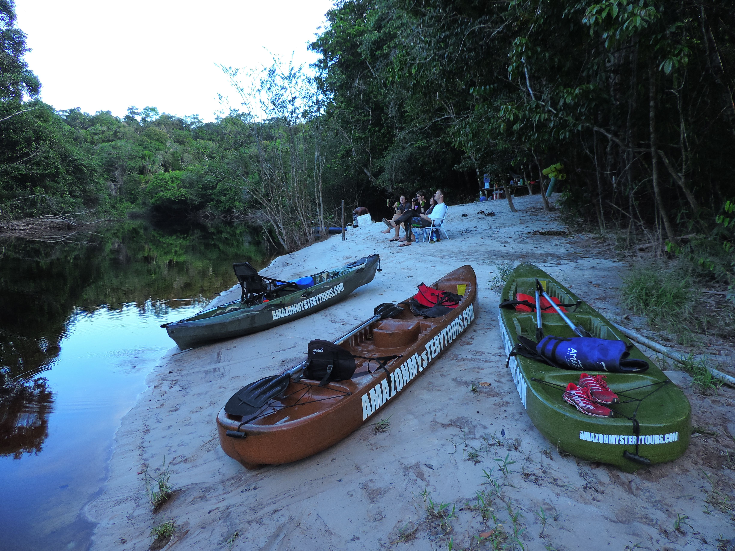
The Urubu River is a tributary of the great Amazon River, and lies to the east of Manaus. It is almost 500 km/310 miles long, and is the narrowest river we travel on – it is the perfect width to experience the real rainforest at your fingertips.

Few people live on this exciting river and you will enjoy peaceful days without seeing or hearing much of humanity at all. The predominantly gentle current will aid you in your journey downstream, although you may also have the chance to shoot some safe but exciting rapids.

Kayaking is the perfect way to experience this beautiful, mystical river before mass tourism discovers it!

SUMMARY OF ACTIVITIES

1. Scenic kayaking
2. Hikes through rare visited rainforest
3. Overnight camp in the jungle
4. Sunrise and sunset observation
5. Meet local forest-dweller/caboclo families
6. White water rapids (in season)
7. Explore a bat cave
8. Hike to a remote and rarely seen waterfall (2x in different ones)
9. Visit the city of Presidente Figueiredo
* Option to tailor activities as time permits - Description in the last pages

ITINERARY

Day 1
08:00 am We’ll meet you in the lobby of your hotel. You can enjoy the Amazonian scenery on the 2-hour drive to the shores of the Urubu, when you will get a feel for the native scenery and local infrastructure.

On arrival, your guide will give you a brief introduction to the kayaks - showing you how to safely enter and exit, how to paddle and steer, and how best to stow your gear. Then it will be into the water for a short swim to help you lose any fear of this beautiful, warm (24C/75F) black water.

11:00 am A little snack and it's time to go! We will kayak for around 2 hours through the luxuriant rainforest where blue and yellow macaws live. This will be your first taste of the true Amazon jungle, the river and its beautiful surroundings. On our first stop, you’ll
be able to stretch your legs during our first hike through the rainforest to see an interesting bat cave often used in the breeding season.

Before leaving for another short stretch of kayaking, we’ll have a refreshing fruit snack - then we'll be on our way to our first campsite, where a nice hot meal will be waiting for us. This camp is located by the wall of a 25 meters (80 ft.) high cliff where tiny orchids cling tenaciously to the vertical surface. This is one of the options of camping it can change with the conditions of the river and season by the way another 2 others camp spots are possible like a dweller shelter or a beautiful beach to see all the stars in our close Line of Ecuador.

Camp will be set up by your guides while you relax and enjoy the famous Brazilian drink, caipirinha (sugar cane liquor with lime, sugar and ice). Your hammock will be covered with a mosquito net and a large tarpaulin on top in case of rain. Your guide will provide a demonstration of some techniques to help you get the best out of your hammock, and then it will be your turn. To minimize any risk of flipping over in your hammock, we suggest you learn these techniques before your third caipirinha ☺ A simple, hot and nutritious dinner will be served before we retire for the night.

Day 2
Breakfast will be served, nice opportunity to new experiences of smells and tastes while you listen all the birds and different sounds of this amazing place. We’ll kayaking around 1hr where we going to do our second hiking and visit 2 waterfalls in the same hiking. This peaceful place is possible jump from the waterfalls in this little stream with the best temperature to refresh our humidity. This hiking in general is made in 2hrs where is possible to have some good knowledge about our plants and first aid in the rainforest. Back to the place where we start the hiking is time to relax and very soon the lunch will be served then Siesta time!

By the afternoon we kayaking again this time with the possibility to have some white rapids on the way depending of course the level of the river. The level of this rapids is easy in a scale of I to VI this stretch is I. Really easy and safe anyway some Adrenaline will be waiting for you. This will also be the longest way of kayaking our sensation of to be in an isolated area is increased. Arrive in the camp spot time to relax our backs contemplate the sunset and wait for our dinner while throw some line hoping to have some luck with the fishes.

Day 3
This will be divided in 3 different times. Morning hiking for the most beautiful and bigger waterfall that we visit in our itinerary by Urubu river.
Our way back will be made by boat against the river. Is good opportunity to take pictures of the way we did. In this way we’ll spent about 3 to 4hrs (it depends of the conditions of the river, sometimes, if to much low pass the canoe way back it a new adventure more hiking will be included and certainly some extra showers ☺) to the same place where we started our Kayaking experience.
Visit the City of Presidente Figueiredo and the waters of Urubui a tributary of Urubu River and then back to Manaus. Arrive about 18:00*

* Subject to vary according to the needs of our customers
Example: Flight.

AMT 04 - KAYAKING EXPEDITION URUBU RIVER – 4D/3N

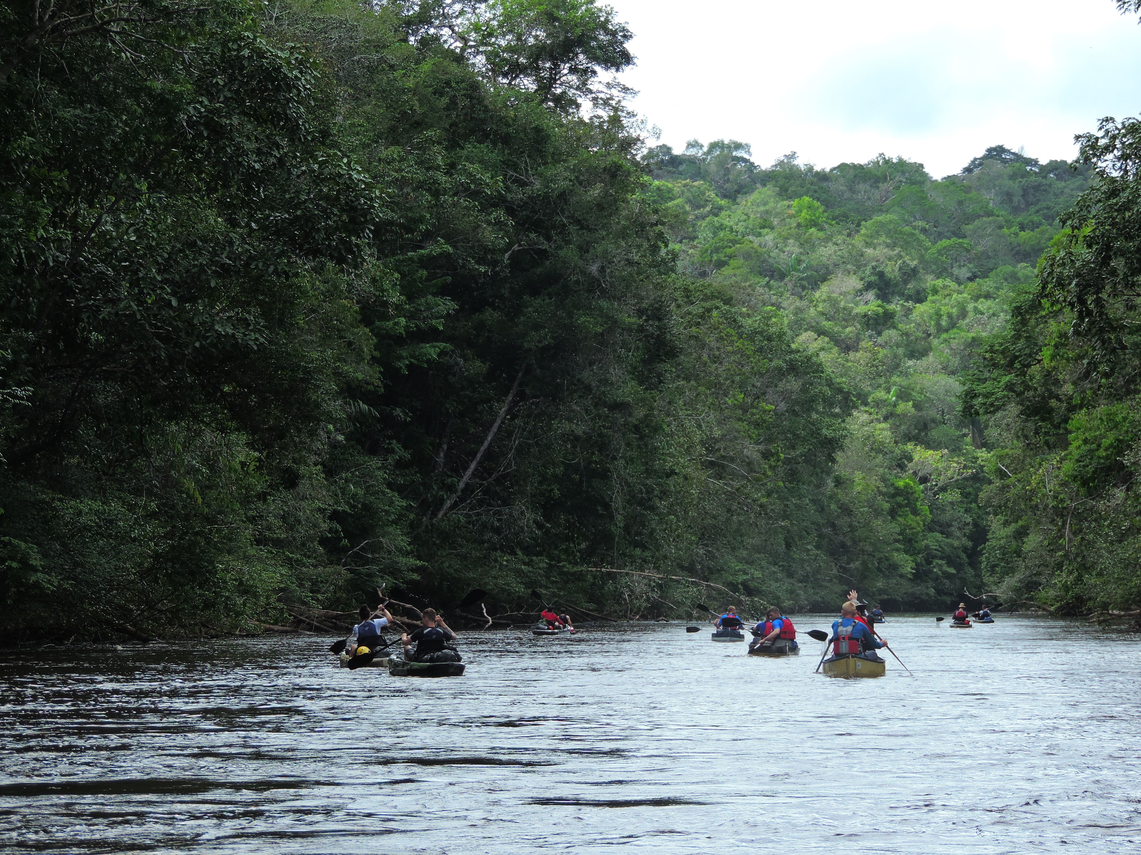

The Urubu River is a tributary of the great Amazon River, and lies to the east of Manaus. It is almost 500 km/310 miles long, and is the narrowest river we travel on – it is the perfect width to experience the real rainforest at your fingertips.

Few people live on this exciting river and you will enjoy peaceful days without seeing or hearing much of humanity at all. The predominantly gentle current will aid you in your journey downstream, although you may also have the chance to shoot some safe but exciting rapids.

Kayaking is the perfect way to experience this beautiful, mystical river before mass tourism discovers it!

SUMMARY OF ACTIVITIES

1. Scenic kayaking
2. Hikes through rare visited rainforest
3. Piranha and peacock bass fishing
4. Nocturnal animal observation (including caiman!)
5. Overnight camp deep in the jungle
6. Sunrise and sunset observation
7. Meet local forest-dweller/caboclo families
8. Overnight in a family’s home (by request)
9. White water rapids (in season)
10. Explore a bat cave (*option 2)
11. Hike to a remote and rarely seen waterfall
* Option to tailor activities as time permits - Description in the last pages

ITINERARY

Day 1
08:00 am We’ll meet you in the lobby of your hotel. You can enjoy the Amazonian scenery on the 2-hour drive to the shores of the Urubu, when you will get a feel for the native scenery and local infrastructure.
On arrival, your guide will give you a brief introduction to the kayaks - showing you how to safely enter and exit, how to paddle and steer, and how best to stow your gear. Then it will be into the water for a short swim to help you lose any fear of this beautiful, warm (24C/75F) black water.

11:00 am A little snack and it's time to go! We will kayak for around 2 hours through the luxuriant rainforest where blue and yellow macaws live. This will be your first taste of the true Amazon jungle, the river and its beautiful surroundings. On our first stop, you’ll be able to stretch your legs during our first hike through the rainforest to see an interesting bat cave often used in the breeding season.

Before leaving for another short stretch of kayaking, we’ll have a refreshing fruit snack - then we'll be on our way to our first campsite, where a nice hot meal will be waiting for us. This camp is located by the wall of a 25 meter (80 ft.) high cliff where tiny orchids cling tenaciously to the vertical surface.

Camp will be set up by your guides while you relax and enjoy the famous Brazilian drink, caipirinha (sugar cane liquor with lime, sugar and ice). Your hammock will be covered with a mosquito net and a large tarpaulin on top in case of rain. Your guide will provide a demonstration of some techniques to help you get the best out of your hammock, and then it will be your turn. To minimize any risk of flipping over in your hammock, we suggest you learn these techniques before your third caipirinha ☺ A simple, hot and nutritious dinner will be served before we retire for the night.

Option 1

Day 2
Remember for 4 days trip we need to hurry to cover 90km (55miles) to the rescue point at the EMBRAPA reserve for this we need to cut some point of our trip for example the cave will be cut. Our estimated along the days will be do 22km (13miles) per day our next point is a nice and exuberant waterfall where we going to visit and then have a delicious lunch and siesta. Along the afternoon kayaking and camping in a beautiful shelter. We can divide the night in a dinner, fun activity like play cards or fishing.

Day 3
By the morning have a good breakfast and paddle down the river for our next stop point. In this way certainly the sense of isolation is complete you almost don’t see anybody for those who looking for peace is a great moment. At this day will have an opportunity to visit or not depends if they are in this area locals with many traditional knowledge.

Day 4 - Last day
On the final day, we will kayak for three hours or so to get to the final destination, a small track within a government-owned agricultural research center. We’ll be met there with our van, and all the gear will be packed up while you have lunch. Afterwards, we will have a 2-3 hours drive through the government’s experimental biodiesel plantations to get to the asphalt road. Finally, there will be an opportunity to stop for cold beers or soft drinks to celebrate the 90km (55 miles) kayak journey before arriving in Manaus around an hour later.

Option 2.

Day 2
We can do peacefully and do more hiking on the way and include for example the Bat cave this way will be back by boat and cover a shorter distance something like 30Km (18miles) the price of course change consult for more information. For those who choose this option this day we’ll do a camping deep in the rainforest for this trek we need to carry our camping and food because of that we need to reorder our packages to just bring the essential. Our activities visit 2 waterfalls and camping deep in rainforest and a hiking at night.

Day 3
Breakfast, hiking by the morning and Kayaking along the river. About 1hr arrive in our next hiking point where we’ll have our lunch, siesta and then a good hiking to visit one of the bigger waterfalls that we visit in our trip along Urubu river. After this great moment we’ll kayaking to stop in our next shelter a beautiful place where at night see the sky while listen the sound of the rapids. This is the best day to fishing or a bigger hiking night to try to see some nocturnal animals.

Day 4 - Last day
Our way back will be made by boat against the river. Is good opportunity to take pictures of the way we did. In this way we’ll spent about 3 to 4hrs (it depends of the conditions of the river, sometimes, if to much low pass the canoe way back it a new adventure more hiking will be included and certainly some extra showers ☺) to the same place where we started our Kayaking experience.

Visit the City of Presidente Figueiredo and the waters of Urubui a tributary of Urubu River and then back to Manaus. Arrive about 18:00*

* Subject to vary according to the needs of our customers
Example: Flight.

Onward as we descend the river, there are a number of activities and sights available to us (see Activities in Detail, below). In consultation with your English speaking guide, you can adapt the precise itinerary according to your own specific interests or requirements. You can repeat, extend or skip activities as you wish – however bear in mind that the limiting factors will be the number of days you have, the water level, security, and your preferred pace. Your guide will help you decide and plan to get the best out of YOUR expedition.

AMT 05 - KAYAKING EXPEDITION URUBU RIVER – 5D/4N

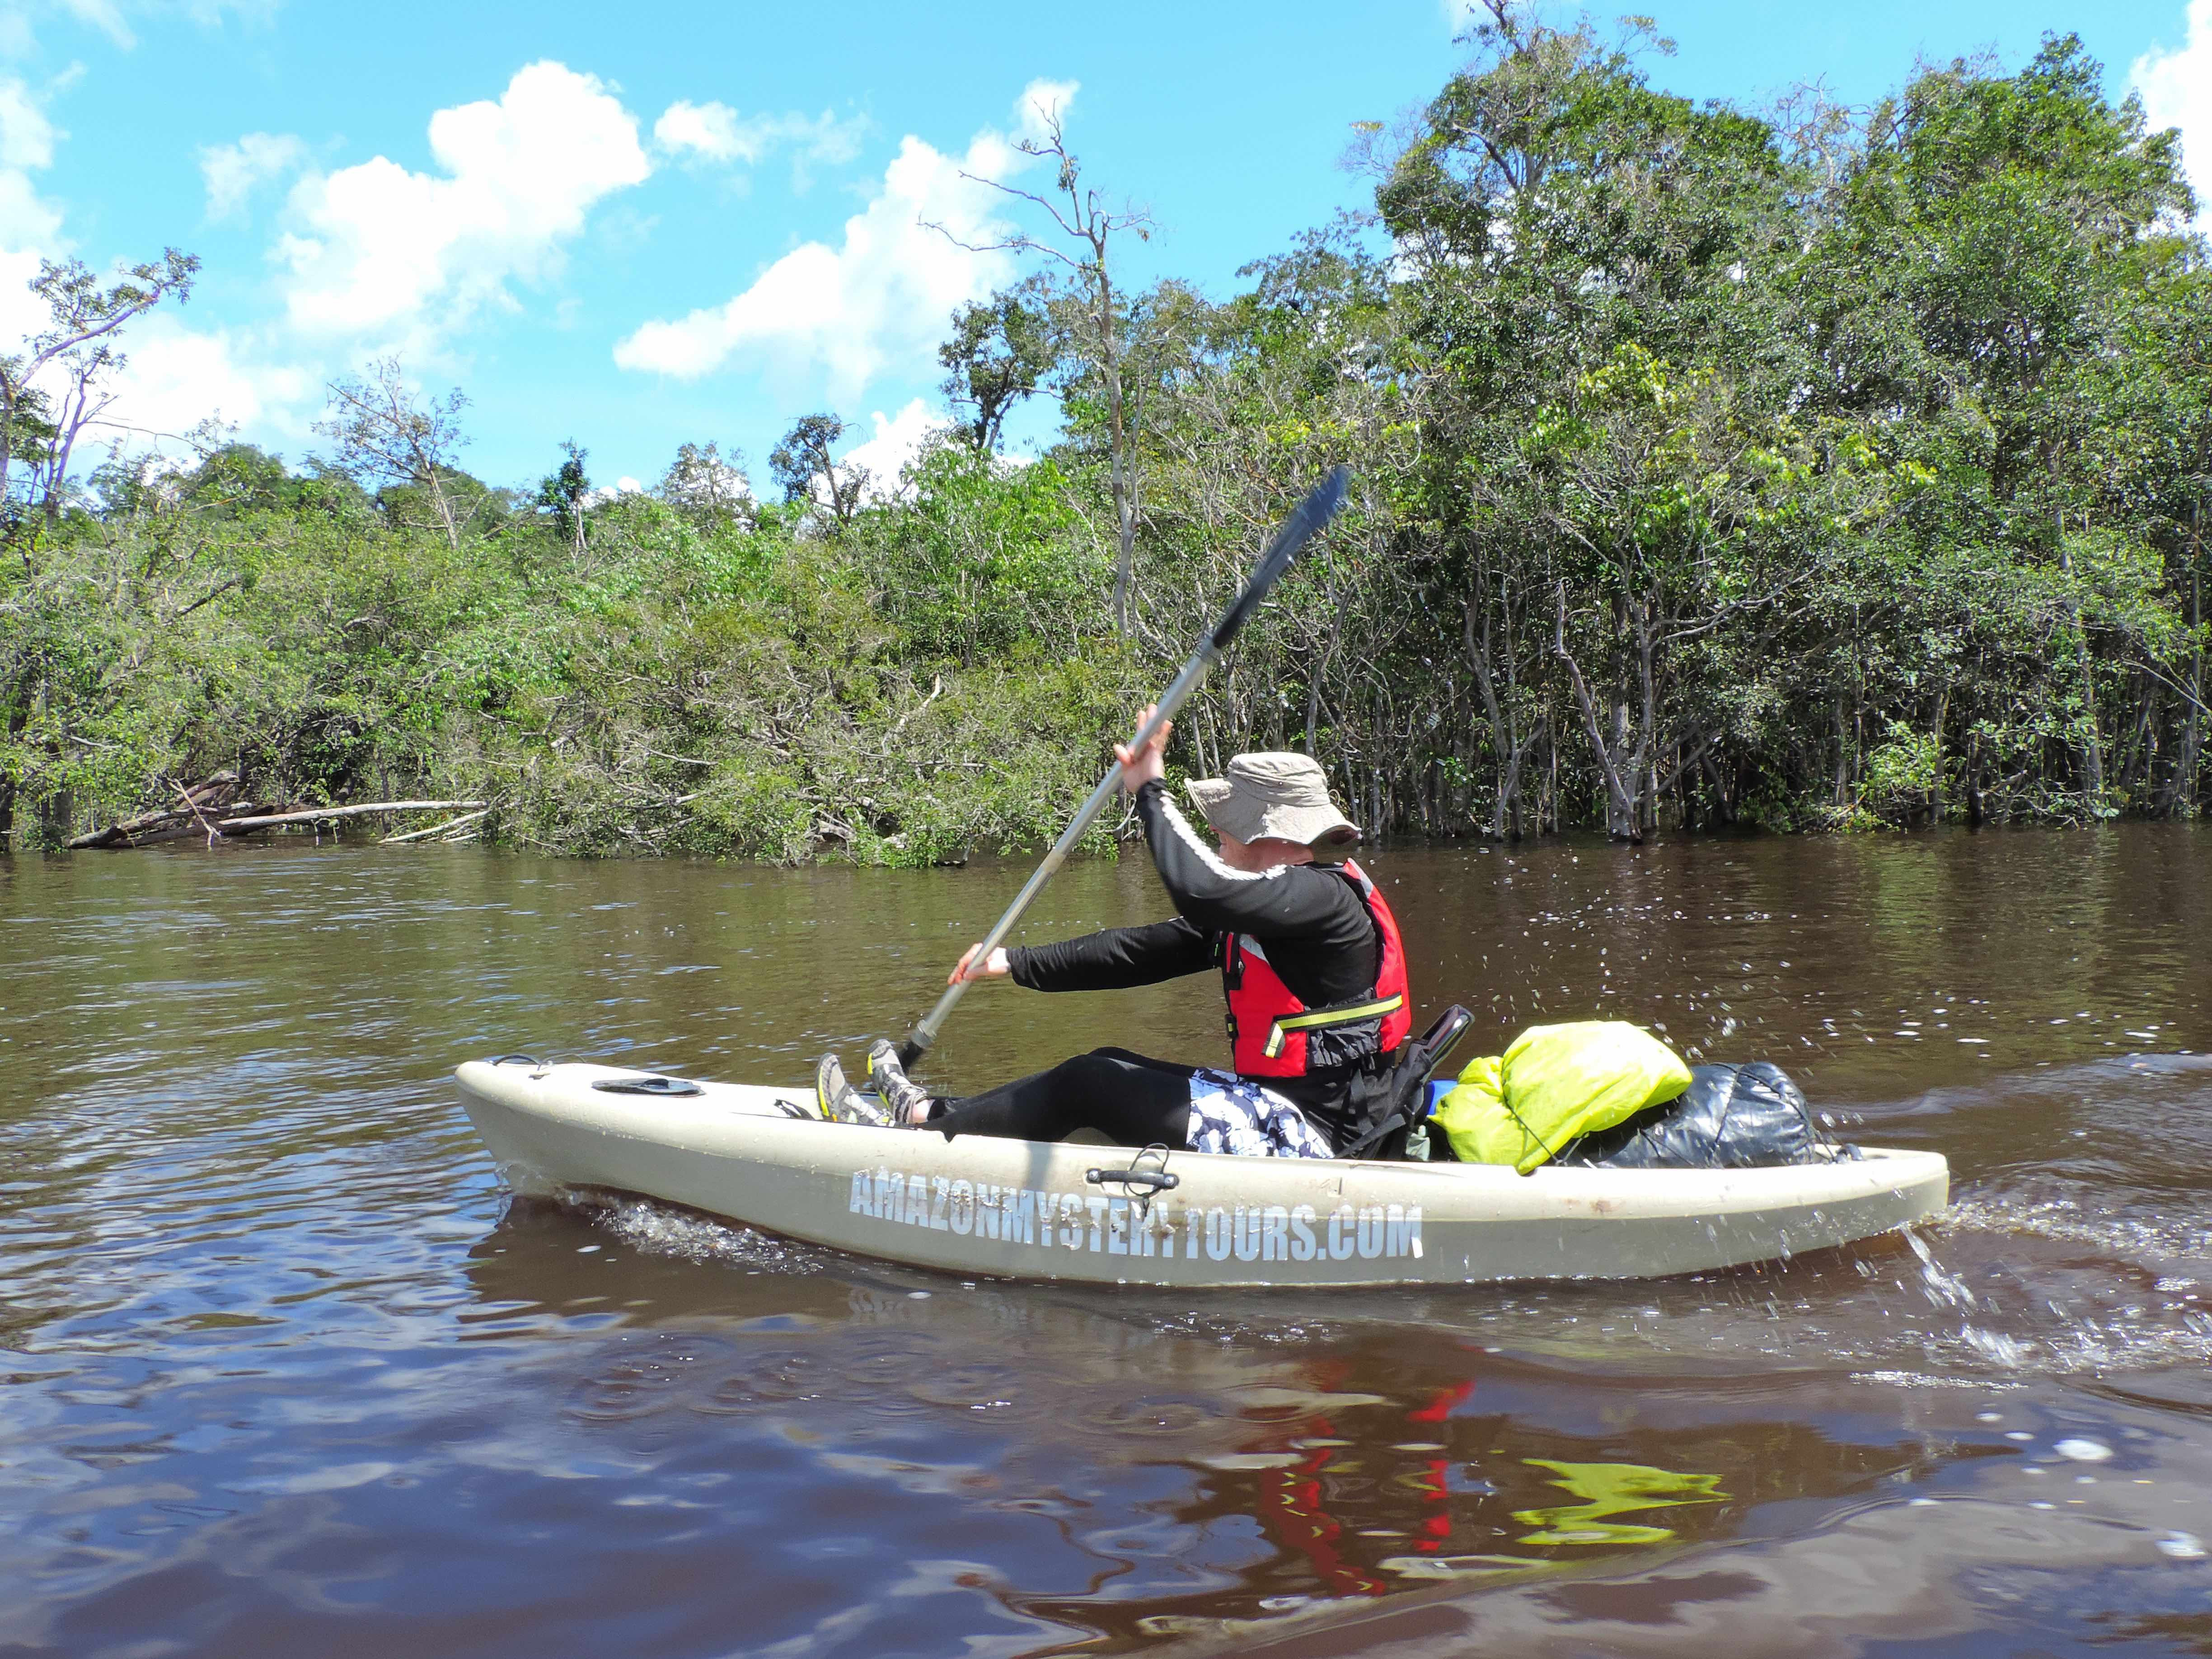
The Urubu River is a tributary of the great Amazon River, and lies to the east of Manaus. It is almost 500 km/310 miles long, and is the narrowest river we travel on – it is the perfect width to experience the real rainforest at your fingertips.

Few people live on this exciting river and you will enjoy peaceful days without seeing or hearing much of humanity at all. The predominantly gentle current will aid you in your journey downstream, although you may also have the chance to shoot some safe but exciting rapids.

Kayaking is the perfect way to experience this beautiful, mystical river before mass tourism discovers it!

SUMMARY OF ACTIVITIES

1. Scenic kayaking
2. Hikes through rare visited rainforest
3. Piranha and peacock bass fishing
4. Nocturnal animal observation (including caiman!)
5. Overnight camp deep in the jungle
6. Sunrise and sunset observation
7. Meet local forest-dweller/caboclo families
8. Overnight in a family’s home (by request)
9. White water rapids (in season)
10. Explore a bat cave
11. Hike to a remote and rarely seen waterfall
* Option to tailor activities as time permits -Description in the last pages

ITINERARY

Day 1
08:00 am We’ll meet you in the lobby of your hotel. You can enjoy the Amazonian scenery on the 2-hour drive to the shores of the Urubu, when you will get a feel for the native scenery and local infrastructure.
On arrival, your guide will give you a brief introduction to the kayaks - showing you how to safely enter and exit, how to paddle and steer, and how best to stow your gear. Then it will be into the water for a short swim to help you lose any fear of this beautiful, warm (24C/75F) black water.

11:00 am A little snack and it's time to go! We will kayak for around 2 hours through the luxuriant rainforest where blue and yellow macaws live. This will be your first taste of the true Amazon jungle, the river and its beautiful surroundings. On our first stop, you’ll be able to stretch your legs during our first hike through the rainforest to see an interesting bat cave often used in the breeding season.

Before leaving for another short stretch of kayaking, we’ll have a refreshing fruit snack - then we'll be on our way to our first campsite, where a nice hot meal will be waiting for us. This camp is located by the wall of a 25 meter (80 ft.) high cliff where tiny orchids cling tenaciously to the vertical surface.

Camp will be set up by your guides while you relax and enjoy the famous Brazilian drink, caipirinha (sugar cane liquor with lime, sugar and ice). Your hammock will be covered with a mosquito net and a large tarpaulin on top in case of rain. Your guide will provide a demonstration of some techniques to help you get the best out of your hammock, and then it will be your turn. To minimize any risk of flipping over in your hammock, we suggest you learn these techniques before your third caipirinha ☺ A simple, hot and nutritious dinner will be served before we retire for the night.

In our trip of 5 days the client can choose between cover 190km (118miles) by kayaking or 90km (55miles) the difference of the trips is point where the vans come to pick up us. The longest way we kayaking on an asphalt road, and, the smallest way we have to drive in a dirt road by 57km (35miles) more appropriate to 4x4. This way from here we will split into two different trips to better explain this:

Option 1:

Day 2
38km (23miles) per day. Breakfast, Kayaking and some stops to refresh. We camping next the rapids and have good dinner. The options like fishing and nightspot are good for this day.

Day 3
38km (23miles) per day. Breakfast, Kayaking and some stops to refresh. Lunch and siesta. We camping in a shelter close the river and have good dinner. The options like fishing and nightspot are good for this day.

Day 4
Any time of our experience our team can help for example if don’t feel well to paddle all the day you can be towed.

38km (23miles) per day. Breakfast, Kayaking and some stops to refresh. Lunch and siesta. We camping in a shelter close the river and have good dinner. The options like fishing and nightspot are good for this day.

Day 5 – Last day
38km (23miles) per day. Wake up early have a breakfast and Kayaking the main characteristic of the longest way we need to spend more time kayaking. Arrive at the Ramal do Banco (asphalted) in the city of Rio Preto da Eva, we have the lunch and drive along the road to Manaus. Finally, there will be an opportunity to stop for cold beers or soft drinks to celebrate the 190km (120 miles) kayak journey before arriving in Manaus around 2 hours later.
Option 2:

Day 2
18km (11miles) per day. Breakfast, Kayaking and hiking to the biggest waterfall in our trip by Urubu river. Lunch, siesta and kayaking to a shelter, beautiful place, where is possible to hear the sounds of nature like the rapids where we sleep close.

Day 3
18km (11miles) per day. Breakfast, Kayaking and some stops to refresh and stretch your back. Lunch, siesta and kayaking to a shelter.

Day 4
Any time of our experience our team can help for example if don’t feel well to paddle all the day you can be towed.
18km (11miles) per day. Breakfast, Kayaking and hiking to the biggest waterfall of our trip along Urubu river. Lunch, siesta and kayaking to a shelter this place we can visit a families along the river if we have luck participate of some of your activities.

Day 5 – Last day of our trip
18km (11miles) per day. On the final day, we will kayak for three hours or so to get to the final destination, a small track within a government-owned agricultural research center. We’ll be met there with our van, and all the gear will be packed up while you have lunch. Afterwards, we will have a 2-3 hours drive through the government’s experimental biodiesel plantations to get to the asphalt road. Finally, there will be an opportunity to stop for cold beers or soft drinks to celebrate the 90km (55 miles) kayak journey before arriving in Manaus around an hour later.

AMT 06 - KAYAKING EXPEDITION URUBU RIVER – 6D/5N

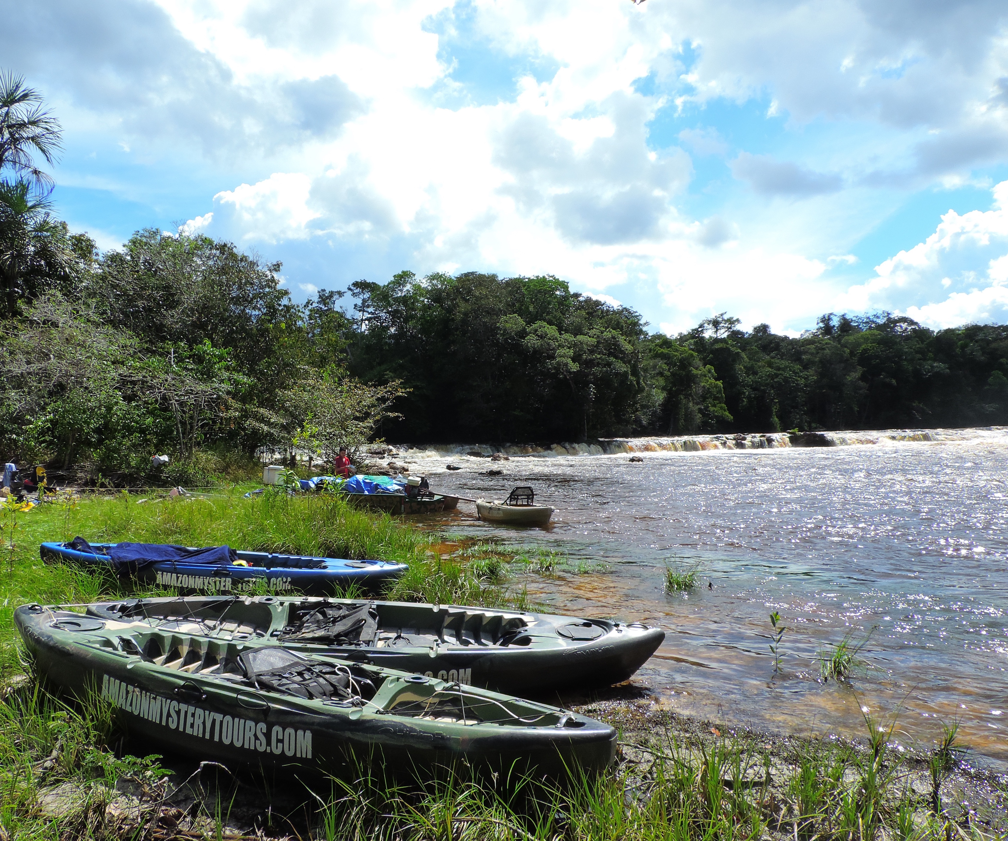
The Urubu River is a tributary of the great Amazon River, and lies to the east of Manaus. It is almost 500 km/310 miles long, and is the narrowest river we travel on – it is the perfect width to experience the real rainforest at your fingertips.

Few people live on this exciting river and you will enjoy peaceful days without seeing or hearing much of humanity at all. The predominantly gentle current will aid you in your journey downstream, although you may also have the chance to shoot some safe but exciting rapids.

Kayaking is the perfect way to experience this beautiful, mystical river before mass tourism discovers it!

SUMMARY OF ACTIVITIES

1. Scenic kayaking
2. Hikes through rare visited rainforest
3. Piranha and peacock bass fishing
4. Nocturnal animal observation (including caiman!)
5. Overnight camp deep in the jungle
6. Sunrise and sunset observation
7. Meet local forest-dweller/caboclo families
8. Overnight in a family’s home (by request)
9. White water rapids (in season)
10. Explore a bat cave
11. Hike to a remote and rarely seen waterfall - Description in the last pages

ITINERARY

Day 1
08:00 am We’ll meet you in the lobby of your hotel. You can enjoy the Amazonian scenery on the 2-hour drive to the shores of the Urubu river, when you will get a feel for the native scenery and local infrastructure.
On arrival, your guide will give you a brief introduction to the kayaks - showing you how to safely enter and exit, how to paddle and steer, and how best to stow your gear. Then it will be into the water for a short swim to help you lose any fear of this beautiful, warm (24C/75F) black water.

11:00 am A little snack and it's time to go! We will kayak for around 2 hours through the luxuriant rainforest where blue and yellow macaws live. This will be your first taste of the true Amazon jungle, the river and its beautiful surroundings. On our first stop, you’ll be able to stretch your legs during our first hike through the rainforest to see an interesting bat cave often used in the breeding season.

Before leaving for another short stretch of kayaking, we’ll have a refreshing fruit snack - then we'll be on our way to our first campsite, where a nice hot meal will be waiting for us. This camp is located by the wall of a 25 meter (80 ft.) high cliff where tiny orchids cling tenaciously to the vertical surface. Camp will be set up by your guides while you relax and enjoy the famous Brazilian drink, caipirinha (sugar cane liquor with lime, sugar and ice). Your hammock will be covered with a mosquito net and a large tarpaulin on top in case of rain. Your guide will provide a demonstration of some techniques to help you get the best out of your hammock, and then it will be your turn. To minimize any risk of flipping over in your hammock, we suggest you learn these techniques before your third caipirinha ☺ A simple, hot and nutritious dinner will be served before we retire for the night.

Day 2
Onward as we descend the river, there are a number of activities and sights available to us (see Activities in Detail, below). In consultation with your English speaking guide, you can adapt the precise itinerary according to your own specific interests or requirements. You can repeat, extend or skip activities as you wish, the water level, security, and your preferred pace. Your guide will help you decide and plan to get the best out of YOUR expedition

Day 3
Breakfast, Kayaking 38km (23miles) per day and some stops to refresh. Lunch and siesta. We camping in a shelter close the river and have good dinner. The options like fishing and nightspot are good for this day.

Day 4
Breakfast, Kayaking 38km (23miles) per day and hiking to the biggest waterfall of our trip along Urubu river. Lunch, siesta and kayaking to a shelter this place we can visit a families along the river if we have luck participate of some of your activities.

Day 5
Any time of our experience our team can help for example if don’t feel well to paddle all the day you can be towed.

Breakfast, Kayaking 38km (23miles) per day and some stops to refresh. Lunch and siesta. We camping in a shelter close the river and have good dinner.

Day 6
On the final day, wake up early have a breakfast and Kayaking the main characteristic of the longest way we need to spend more time kayaking. Arrive at the Ramal do banco in the city of Rio Preto da Eva, we have the lunch and drive along the road to Manaus. Finally, there will be an opportunity to stop for cold beers or soft drinks to celebrate the 190 km (120 mile) kayak journey before arriving in Manaus around 2 hours later.

ACTIVITIES IN DETAIL

1. SCENIC KAYAKING:

You will immerse yourself (not literally, we hope) in the beauty of the Amazon jungle and the Urubu river within the first 2 hours of kayaking through the luxuriant rainforest. During the whole expedition you will experience a variety of waters - some shallow, relaxing areas with flat rocks and others which provide a more thrilling ride (we find the possibility of tipping your canoe over in the rapids sharpens the senses wonderfully). ☺ Early morning kayaking (6:00 am) is a good choice since it provides the best chance to see rare animals like tapirs, electric eels and the magnificent harpy eagle. Night kayaking is also exciting, when we head out for our Nocturnal Animal Observation, including caiman spotting. On the lower part of the Urubu, we will pass through a completely different rainforest ecosystem, where the river is larger with some small lake-entrances along the banks. We will have left any rapids behind us, and now in the very quiet streams we may see monkeys, coatis (raccoon family) and white herons.

2. HIKES THROUGH VIRGIN, UNINHABITATED JUNGLES:

Some areas of the Urubu are in the higher land ecosystem with hundreds of unique plant species and trees up to 60 meters (200ft) high. In this ecosystem the intertwined canopy in some areas can totally block the passage of light, making the area extremely humid, dark and with little ventilation - yet amazingly beautiful. Hiking activities will have you trekking in this higher land rainforest. We may need to clear trails as we go and stop frequently when we find interesting medicinal plants, plants with resins to make torches, water-vines and many other fascinating species. Your guide will use all his knowledge and experience to identify these plants for you and show you how to live from the rainforest with some basic survival techniques. Hiking at night presents its own challenges, thrills and rewards, and you will have the opportunity to do this when we go camping overnight in the forest. ☺

3. PIRANHA AND PEACOCK BASS FISHING:

Around 15:30 (3:30 pm) is the time for piranha or peacock bass fishing! While we fish, it’s a perfect opportunity to become more aware of our environment and with luck (and quiet) we may see some interesting wildlife - it is a perfect time to see pairs of green parrots flying home to roost, for example. We'll fish until around dusk, before we make our way to camp. There, the guides will either prepare a normal meal or (if your fishing was successful!) a piranha fish soup – a famous aphrodisiac.

4. NOCTURNAL ANIMAL OBSERVATION:

We’ll do this after sunset using spotlights to locate the animals by looking for the reflection of the light from their eyes. Your guide will try to catch a caiman without hurting the animal (or himself) using his experience and techniques. If you’re feeling brave enough, you may hold the caiman, provided it’s not over a meters (3ft) long. Once your guide has had the opportunity to tell you more about the animal, he will carefully set it free. Other nocturnal animals like spiders, snakes, owls or giant frogs may also be seen.

IMPORTANT NOTE (activities 3 & 4): Fishing and caiman-spotting are dependent on the season. Specifically, the low-water season (September - February) provides better chances to encounter these animals, while at high water the rivers (and the aquatic fauna) spread into the flooded forest, making them harder to find.

5. OVERNIGHT CAMP DEEP IN THE JUNGLE:

Late in the afternoon, the rainforest tracker will guide us as far as we wish for the overnight camping in the deeper rainforest. Basic camping gear, smaller hammocks and prepared food will be put in everyone’s day packs and carried with us. This is a once in a lifetime experience, to be deep in the primary Amazonian rainforest, in total darkness, listening to and trying to view nocturnal animals. Most animals are not seen during the day as 80% are nocturnal. Sometimes, animals may come very close to the campsite, as we don’t make any fires. This is a safe but thrilling experience ☺

6. SUNRISE AND SUNSET OBSERVATION:

Sunrise and sunset in the Amazon are around 6:00am and 6:00pm respectively. The combination of the yellow, orange and reddish colors in the sky filtered by the greens and browns of the forest and blending with the dark waters of the river is enchanting. When the waters are quite still, the reflection is so perfect that it is often difficult to distinguish where the water ends and the forest and skyline begin. It can be one of the most beautiful images the Amazon has to offer. The sounds of the birds and animals waking up or settling down for the night complement this unique atmosphere.

7. MEET LOCAL FOREST-DWELLERS IN FAMILIES AND/OR SMALL COMMUNITIES:

The locals are very friendly and receptive, and you can experience first hand the realities of life in the forest. You can learn about the traditional manioc (cassava) plant processing, and discover how they extract the poisonous liquid from the roots. If you are lucky, you may see local people carving a canoe or building a much larger homemade 15 meters (40ft) wooden fishing boat. In exchange for the visit, sometimes visitors like to give gifts of school supplies like colorful crayons, perfumes, or maybe a soccer ball.

8. OVERNIGHT IN A FAMILY’S HOME (BY REQUEST):

If you’d like to extend your cultural encounter, an overnight with a local family can often be arranged. The family will make you very welcome in their simple but safe and secure home. No air-conditioners or hot showers, but certainly a good roof over your head and a happy and relaxed atmosphere. This is normally done on the last night of the trip when everyone is a bit tired and happy to take a break from the activities or the chores of making camp. ☺

9. WHITE WATER RAPIDS (in season):

This activity is dependent on river levels. If it is the right time of year, your guide will, ‘encourage’ you through some exhilarating rapids formed by the shallow waters running over large rock plates on the river bed. This is a thrilling and refreshing experience which everyone always enjoys.

10. EXPLORE A BAT CAVE (except on the 4 days tour):

For this activity, we will hike through the rainforest for some 30 minutes until we reach an interesting bat cave used in the breeding season. After squeezing yourself through a low/narrow rock passage, you'll emerge in a spectacular main chamber where a little waterfall runs through a hole in the center of the roof. Sometimes small caiman/alligators rest in the bottom of the shallow rocky pool. Swimming is not recommended here.☺

11. HIKE TO A REMOTE AND RARELY SEEN WATERFALL:

1.Less than 30 minute’s hike will bring you to a very remote, little-known waterfall, where it is possible to swim, climb a small cliff on the side of the falls and go behind the waters into a tiny cave that olds up to 3 people. Then, climbing a few more meters by holding on to roots and rocks, you arrive at a second ledge behind the falls and from where you can enjoy the wonderful and unique view. It’s awesome!

2 waterfalls in the same day. This peaceful place is possible jump from the waterfalls in this little stream with the best temperature to refresh our humidity.

12. CANOPY TREE-CLIMBING:

This activity usually takes half a day from start to finish and can be incorporated in the first day of your trip so, it’s not necessary to add another day into your trip. An excellent choice to put your overall experience literally to the top. This is not the common tree-climbing in this sport adventure place you just not add the tree climbing but Zip-line, Canoe, Slip’N Slide, Amazonian knowledge Track and more. This is an authentic experience in the rainforest very close where we start the Kayaking trip. For security reason we hire professionals for this service, you'll be in secure hands and we guarantee, the sensation going up to the canopy is breathtaking.

KAYAKING THE URUBU with Amazon Mystery Tours - an unforgettable experience

